Ms. Joyce Lambert
FEI Jumper Judge, USEF “R” Judge Hunter/Jumper/Hunt Seat Equitation/Hunter Breeding, NSBA Specialized Jumping Judge, USHJA Certified Trainer, CHA Assistant Certifier
MHJA Local Member Show
February 18 & 19
Followed by a clinic with our judge, Joyce Lambert, February 20 & 21
Proudly hosted by Windermere Equestrian Center

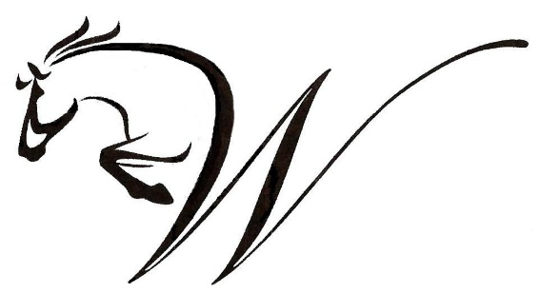
Joyce Lambert is a lifelong horsewoman experienced in all aspects of the equine industry. Her resume is extensive. Joyce has done it all - from developing equestrian programs, managing multiple equestrian facilities, and managing staff and production for Equine Sports Production.
In addition, Joyce maintained and managed an active show facility. Clients and horses, from beginners through those competing at the upper levels, were prepared for the Hunter/Jumper horse show arenas. Those clients competed at “AA” and “A” USEF shows on a weekly basis, earning USEF and USHJA year-end awards while qualifying and competing at USEF Pony Finals and Marshall & Sterling League Finals.
Young and/or rescue horses were included in the program. Joyce also coached IEA middle and high school riding teams for three years, created a non-profit corporation for the teams, and served as regional chair for the North Florida IEA Zone.
Joyce is also experienced with equine reproduction, from insemination or live cover, gestation, delivery, competing on the line, and backing.
Clinic Cost: $375.00
Stall: $70.00
One Show Division: $75.00
Two Show Divisions: $135.00
Tentative Clinic Schedule (2/20 & 2/21)
Session 1 8:30 AM – 10:00 AM
Session 2 10:15 AM – 11:45 AM
Lunch and Discussion
Session 3 1:00 PM – 2:30 PM
Session 4 2:45 PM – 3:30 PM
Question & Answer
Running the horse show prior to the clinic will allow Joyce to observe the riders’ and horses’ performances during competition, when nerves and anxiety can be a factor. With advanced knowledge of the participants’ strengths and weaknesses, Joyce can tailor the training days to the groups’ specific need.
This clinic will be run differently than most. Instead of signing up for particular sessions, the clinician will divide the participants into four training groups based on her observations during the show and the short bio written by each participant upon acceptance into the clinic (she will not see these before the show).
Clinic groups and session times will be posted Sunday afternoon upon completion of the show day.
Important Information
*All clinic participants must compete in at least one division in the show on 2/18 & 2/19, and be showing 2’ or above.
*Clinic participation is first-come, first-serve. Each group will have 6 riders maximum. We will confirm a spot once an entry form and clinic application is received.
*You may compete in the horse show without participating in the clinic.
*The show will run with USHJA “like” divisions for hunters/equitation and jumpers. Open to amateurs, juniors, and professionals in the hunter and jumper divisions. Open to amateurs and juniors only for the equitation divisions.

For more information, please contact info@windermereequestrian.com
Audit Fee: $25 per day (will send out more information on how to purchase soon!)
$30 at the door
All horse show participants will receive a free audit ticket for themselves and a guest with their show entry.

